1. Overview

A platform is where players access and play your game. The platform can refer to the store or ecosystem where players find your game (like Steam or the App Store). But it can also refer to the hardware your players use to play your game (like a PC, phone, or console).
Up until now, you've probably only configured controls for a computer or desktop experience. But what if you want to expand your game to mobile devices, consoles, or even dive into the realms of virtual reality (VR) and augmented reality (AR)?
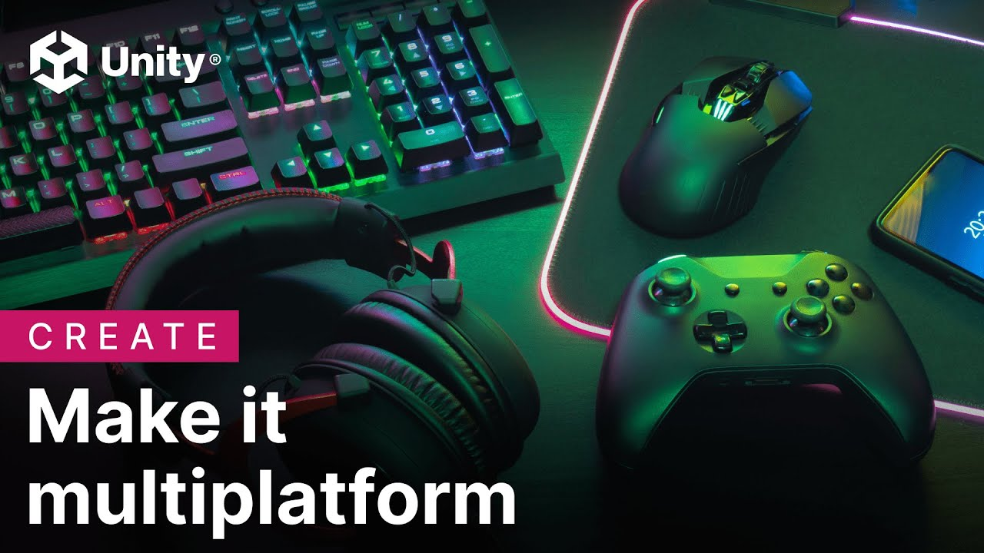
Unity's motto, "Build once, deploy anywhere" captures one of the engine’s most powerful features: you can develop your game once and then deploy it on multiple platforms with relatively minor edits. This cross-platform capability is vital in game development because it broadens your game's reach and audience.
In this lab, you’ll learn about the different platforms, including important implications of choosing one over the other.
Note: For this learning pathway, you’ll focus on developing for platforms you can conveniently access and test on. PC/Mac or browser-based WebGL (for example, Unity Play) are the most accessible starting points for Unity developers.
Mark step complete
2. Publishing platforms and consoles

Unity can target over 25 publishing platforms, including the following:
- Console platforms – PlayStation ®, Xbox ® (each with its own store and certification process)
- Mobile app stores – Apple App Store, Google Play Store
- Web and social platforms – WebGL builds on websites or browser game portals such as itch.io and play.unity.com
- PC stores – Steam, GOG, itch.io
- VR stores – Meta Quest Store, PlayStation VR, SteamVR
Why publishing platform matters for design
- Audience and expectations: Console and PC audiences might expect deeper controls and longer sessions, while mobile audiences often expect games designed for accessibility and broad appeal, with the ability to play in short bursts.
- Technical and content limitations: Each platform has its own policies, file size limits, performance requirements, and sometimes content rules.
- Certification and approval: Console platforms require lengthy certification processes and may have submission fees.
You don't have to know every detail, but if you choose "PC via Steam" vs "mobile," you're also making certain design commitments and constraints.
Mark step complete
3. Understanding the differences between platforms

Porting is the process of adapting your application from one platform to suit another.
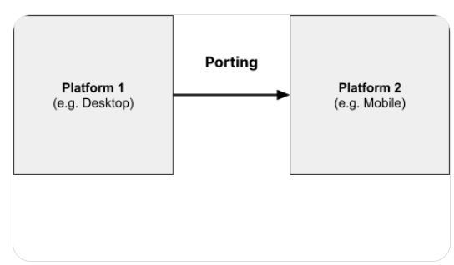
This can be relatively straightforward when moving between similar platforms (like from macOS to Windows). However, things get a bit more complicated when the platforms are quite different, like moving from a PC to a mobile device.
Controls
Each platform has its own unique controls. For instance, desktop games typically use a keyboard and mouse, mobile games use a touchscreen, console games use a controller, and VR games use a headset and hand controllers. When porting your game, consider how these differences will affect gameplay. For example, a fast-paced shooter game designed for a keyboard and mouse might struggle with a touchscreen's lack of precision.
If you’re interested, check out the following video where a Unity engineer explains how Unity’s input system tries to handle a variety of different controls.

Screen size and aspect ratio
Different devices come with different screen sizes and aspect ratios. The aspect ratio describes the relationship between the width and the height of a screen.
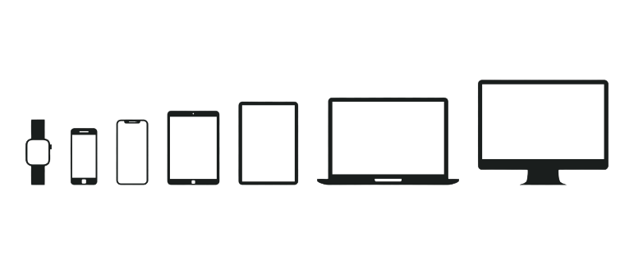
For example, consoles are often played on TVs, while mobile devices have small screens that can be either portrait or landscape, and VR and AR offer a wholly different screen experience. When porting your game, you may need to adjust UI elements and camera views to accommodate these differences. A UI that looks perfect on a 24 inch desktop screen might be illegible on a 5 inch smartphone.
Processing power
Processing power varies widely across platforms. Desktops can range from old laptops to high-end gaming towers; consoles have specialized hardware for processing high-end graphics, while mobile, web, or VR platforms could have more limited power. A game with simple graphics may be easy to port to any platform, but a highly detailed 3D game designed for a powerful gaming PC may struggle on a mobile device.
Example
Consider the example of the popular game Among Us. Initially created for PC and mobile, it was later ported to VR as Among Us VR in 2022. Every asset and interaction had to be entirely redesigned to succeed in this porting process.
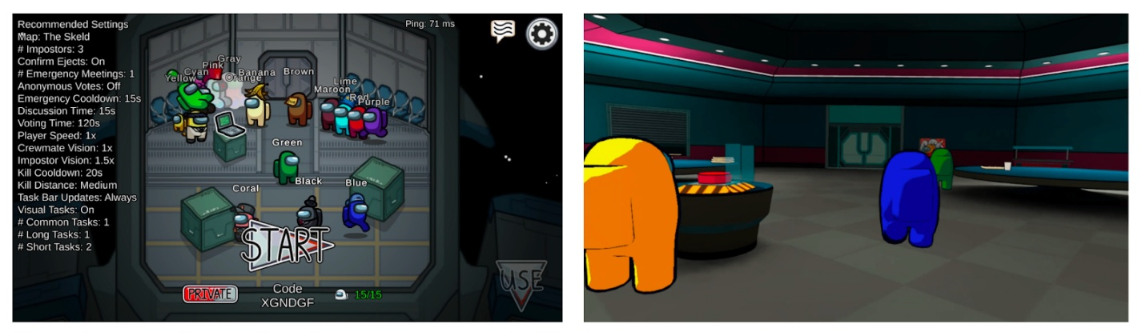
Left image from Among Us press kit. Right image from Among Us VR press kit

4. How genre and platform inform design
Your game’s genre and platform choice are closely related. Certain genres thrive on specific platforms because of how input, session length, and context of play align.
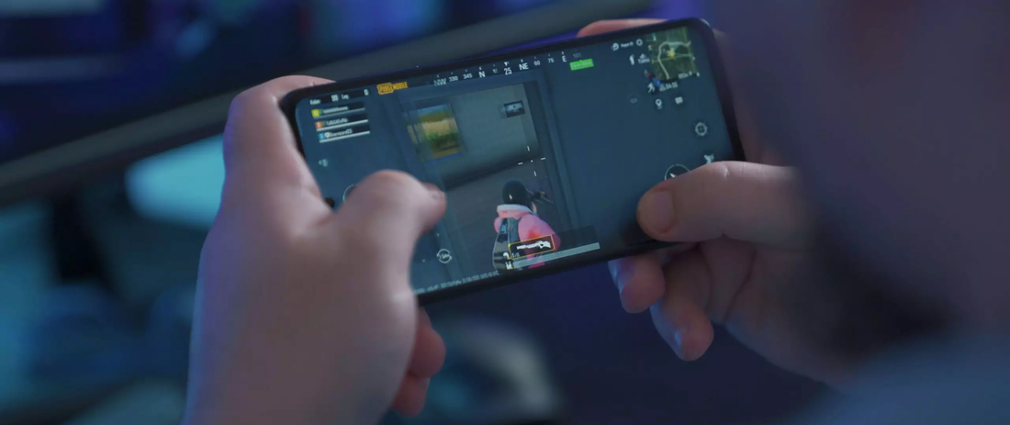
Why Match-3 Puzzle games dominate mobile
Games like Candy Crush and Bejeweled succeed on mobile for the following reasons:
- Quick sessions: You can play one level in 2-3 minutes (perfect for waiting in line or commuting)
- Touch-friendly input: Swiping and tapping gems feels natural and precise on a touchscreen
- One-handed play: You can play with phone in one hand on a crowded bus
- Low cognitive load: They’re easy to put down and pick up without losing progress
- Portrait orientation works: They matches how people naturally hold phones
Contrast this with a fast-paced shooter on mobile:
- Virtual joysticks feel imprecise compared to mouse or controller
- Require both hands and full attention
- Difficult to play in short bursts
- Small screen makes it hard to spot distant enemies
Why strategy games often target PC/Mac
Games like Cities: Skylines and StarCraft work well on a desktop computer for the following reasons:
- Mouse precision: Selecting units, placing buildings, and managing UI is fast and accurate.
- Screen real estate: Large monitors let you see the whole battlefield or city at once.
- Long sessions: Players expect to spend 30+ minutes in a single session.
- Keyboard shortcuts: Power users can master complex hotkey systems.
Modding community: PC players often create mods (harder on console and mobile).
Mark step complete
5. Cross-platform design considerations
Unity makes it possible to build your game for multiple platforms from a single project. However, designing a game that works well across multiple platforms simultaneously requires careful planning.
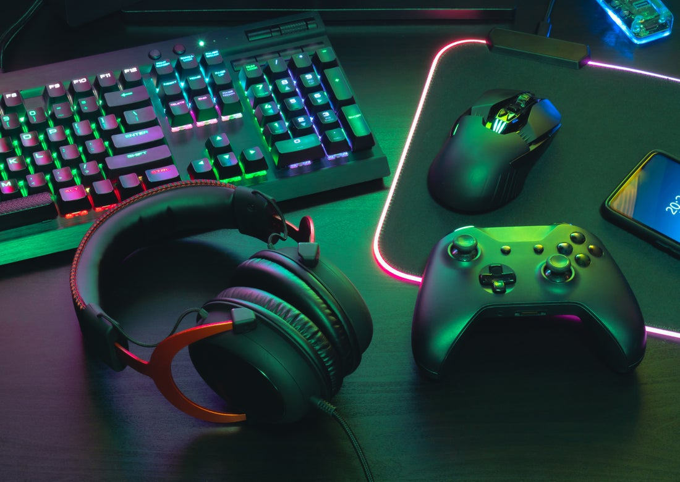
Adaptive design approaches
When targeting multiple platforms, you have two main options:
1. Design for the lowest common denominator
- Design your game around the most limited platform you're targeting.
- For example, if targeting both mobile and PC, design controls that work well on touchscreen, then adapt them for keyboard/mouse.
- Advantage: Ensures consistent experience across all platforms.
- Disadvantage: May not take full advantage of more capable platforms.
2. Platform-specific adaptations
- Design core gameplay to be platform-agnostic, but customize controls, UI, and pacing for each platform.
- For example, Dead Cells redesigned its controls entirely for its mobile version while keeping the core gameplay intact.
- Advantage: Each platform gets an optimized experience.
- Disadvantage: More development time and testing required.
Technical considerations in Unity
Unity provides platform-specific APIs and settings that allow you to develop for multiple platforms.
- Input System: Unity's Input System allows you to define abstract "actions" (like "Jump" or "Attack") and map them to different inputs per platform. This means one codebase can support keyboard, gamepad, and touch simultaneously.
- Platform directives: You can write code that only runs on specific platforms:
#if UNITY_IOS
// Code that only runs on iOS
#elif UNITY_ANDROID
// Code that only runs on Android
#elif UNITY_STANDALONE
// Code that only runs on PC
#endif
- Build Settings: Each platform has specific build settings for resolution, graphics quality, and performance optimization. You can create different Build Profiles optimized for each target platform.
6. Accessibility considerations
Different platforms have different expectations for accessibility features. As you design, consider these basics:
- Visual: Colorblind-friendly color palettes, adjustable text size, clear contrast.
- Audio: Visual alternatives to important audio cues (subtitles, visual indicators).
- Motor: Remappable controls, adjustable timing windows, aim assist options.
- Platform requirements: Consoles often require certain accessibility features for certification (button remapping, subtitle support). Mobile should support system-level text size settings. VR must include comfort options to reduce motion sickness.
Unity’s Scripting API includes an entire Accessibility module dedicated to helping developers integrate accessibility features into their projects.
For more guidance, see the Game Accessibility Guidelines website.
7. How monetization shapes design
For this learning pathway, you're likely building a portfolio piece or learning project, so monetization won't be your focus. However, understanding how games make money will help you analyze professional games and understand why they're designed the way they are.
Monetization strategy isn't just a business decision; it directly shapes core design choices like progression pacing, session length, and what content is available upfront vs. unlockable.
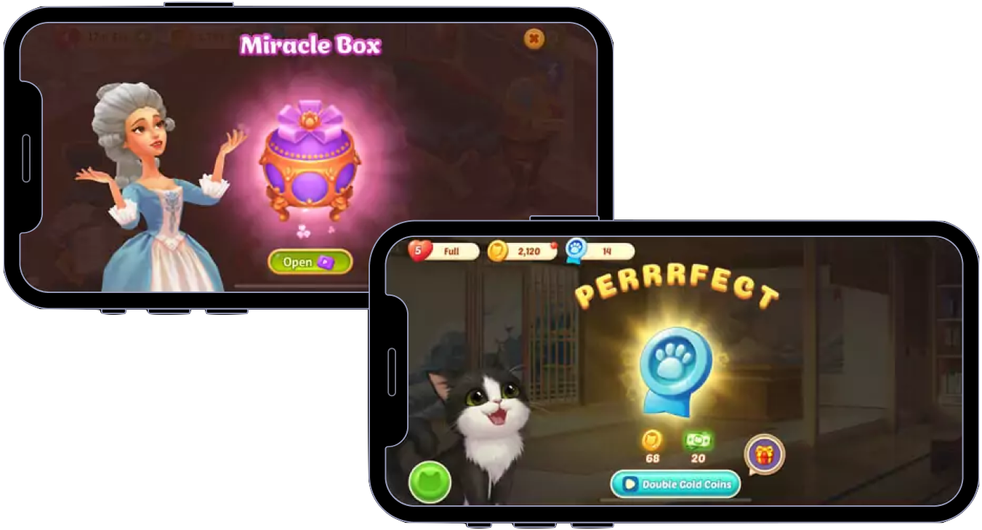
Here are the three main monetization models and their design implications:
Free-to-play (F2P) with In-app purchases (IAP)
- What it is: The game is free to download; revenue comes from optional purchases (cosmetics, convenience, power).
- Common on: Mobile, increasingly on PC.
- Design implications:
  - Must design for retention — players need reasons to return daily/weekly.
  - Often includes daily quests, login bonuses, limited-time events.
  - Progression may be slower to encourage purchases of time-skips or boosts.
  - Risk of "pay-to-win" hurting player experience if not balanced carefully.
  - Need to balance free players (who provide community) with paying players (who provide revenue).
- Example: Genshin Impact, most mobile puzzle games.
Ad-supported
- What it is: Game is free; revenue comes from showing ads (banner ads, video ads, rewarded ads).
- Common on: Mobile (especially more casual games).
- Design implications:
  - Short, repeatable sessions work well, since players see more ads.
  - Rewarded ads can be designed into progression ("watch ad for extra life").
  - Must balance ad frequency; too many ads and players uninstall.
  - Often paired with "pay to remove ads" option.
- Example: Many mobile endless runners, casual puzzle games.
Premium (pay once)
- What it is: Players pay upfront ($5-$60) to own the game.
- Common on: PC (Steam), Console, certain mobile titles.
- Design implications:
  - No need to artificially slow progression or create friction points.
  - Can design complete, self-contained experiences.
  - Players expect substantial content for their money.
- Example: Hollow Knight, Cuphead
Reflection question
Think of a free mobile game you've played. Can you identify one design choice that was clearly influenced by the monetization model?
Examples: energy systems that refill over time, cosmetic shops, daily login rewards, rewarded video ads).
8. Complete the Future features and open questions section of your GDD

Now that you’ve learned about game design, game genres, and game platforms, you are ready to fill out the final sections of your GDD.
First, the Additional mechanics section captures ideas for features you might add if time allows, or in future iterations.
Additional mechanics (nice-to-haves)
List features that would enhance your game but aren't critical for the core experience:
Examples
- Power-ups: Temporary speed boost, invincibility, magnet that attracts pickups.
- Level variety: Multiple environments with different visual themes.
- Progression system: Unlockable player types, difficulty modes.
- Polish elements: More particle effects, dynamic music, animated UI transitions.
For each feature
- Brief description
- Priority level (High/Medium/Low)
Example
"Speed boost power-up (Medium priority): A temporary star pickup that increases player speed by 50% for 5 seconds.”
To do
Fill out the Future Features section now.
Known issues or design questions
Optional
Document any aspects of your design you're uncertain about or want to improve.
Examples
- "The difficulty curve might be too steep."
- "Not sure if the enemy should patrol or chase the player."
- "Need to experiment with different camera angles for better visibility."
This helps you track design problems to solve in future iterations.

Mark step complete
Optional step
9. Complete the optional sections of your GDD
In this unit, you learned about other elements that you might find in a professional GDD, which are not as relevant for this learning project. If you’re interested in a more comprehensive GDD, fill in the additional sections below. Otherwise, feel free to skip to the end of this lab and delete these sections from your GDD.
Player experience
Core loop
You learned that the core loop is the sequence of actions the player repeats most of the time.
Examples
- Roll → Collect → Dodge → Repeat
- Fly → Weave → Collect → Score
- Move → Avoid → Grab → Escape
To do
Fill out the Core Loop section now.
Difficulty curve
You learned in the Game design lab that a difficulty curve is how difficulty changes over time, designed to keep players engaged without becoming bored or frustrated.
Example
- "Obstacles start far apart with generous reaction time. Gap between obstacles gradually decreases. After reaching a score of 50, obstacles begin appearing in pairs."
To do
Fill out the Difficulty Curve section now.
Player experience / Game feel
The player experience is what it feels like — emotionally — to play your game. You can aim for feelings like the following:
- Relaxed and cozy
- Tense and focused
- Clever and satisfied
- Powerful and dominant
- Chaotic and silly
To do
Fill out the Player Experience / Game Feel section now.
Target market
Genre
Refer back to the Game genres lab if you need to refresh your understanding of genres and player verbs.
Your game likely falls into one or more of these categories:
- Casual: Simple mechanics, short sessions, broad appeal.
- Action: Fast-paced, reflex-based challenges.
- Arcade: Score-focused with increasing difficulty.
You can also describe your game as a hybrid genre:
- "Casual action game"
- "Arcade platformer"
- "Action-puzzle hybrid"
To do
Fill out the Genre section now.
Target audience
Who is this game for? Consider the following:
- Age: Children (6-12), teens (13-17), adults (18+), all ages.
- Player type: Casual players, puzzle enthusiasts, action fans, completionists.
- Experience level: First-time gamers, moderate experience, hardcore gamers.
Example
"This game targets casual players of all ages who enjoy short, satisfying gameplay sessions with clear goals and gradual difficulty increases."
To do
Fill out the Target Audience section now.
Target platform
For this learning project, focus on platforms you can actually test:
- PC/Mac (via standalone build)
- WebGL (browser-based, for example, Unity Play, itch.io)
You can also note aspirational platforms:
- "Initially designed for PC/WebGL, with potential mobile adaptation in the future."
Answer these questions in the Target Platform section
- What platform(s) are you building for?
- What input method will players use? (Keyboard/mouse, gamepad, touch controls).
- What screen size are you designing for? (Desktop monitor, phone, tablet).
Optional consideration
"If I adapted this for mobile, I would need to [add touch controls / simplify UI elements / adjust session length]."
To do
Fill out the Target Platform section now.
Monetization considerations
Even though this is a learning project, considering monetization helps you understand how business models shape design.
If you were to publish this game
- What monetization model would you use? (Premium, F2P with IAP, Ad-supported).
- How might that choice influence your design? (Progression pacing, session length, retention hooks).
Example
"If this were a mobile F2P game, I might add daily challenges to encourage return visits, or offer cosmetic skins for the player character. I would avoid pay-to-win elements and keep the core gameplay fair and skill-based."
Development timeline
A timeline helps you track progress and set realistic milestones. The template includes placeholder milestones focused on enhancement tasks that line up with the units of this pathway. Feel free to edit these milestone names, adjust time estimates, or create a completely different timeline structure that works better for your project.
Consider using professional task tracking tools
While a simple timeline in your GDD works for this project, many developers use dedicated task management software to stay organized.
Industry-standard tools include the following:
- Trello (visual boards with cards)
- Jira (used by many game studios for agile development)
- Notion (flexible docs and databases)
- Asana (project management with timelines)
Using these tools helps you break large milestones into smaller tasks, track progress visually, and develop habits used in professional game development teams. Many offer free tiers, which are perfect for solo or small projects.
To do
Review the Development Timeline section in your GDD template. Edit the milestones to match your actual priorities, or keep the placeholders as a starting framework.
Mark step complete
10. Next steps
In this lab, you learned how platform choices can shape fundamental design decisions. You explored why certain genres thrive on specific platforms, and what cross-platform design entails.
You also filled out the remaining sections of your GDD.
Before you begin implementing these design choices, in the next lab you’ll set up version control on your project.

